# Brainstorm

**TIP**

You can select a sticky note and hit the pencil [switch to sketch] icon to start drawing!

## Before you collaborate

A little bit of preparation goes a long way with this session. Here’s what you need to do to get going.

**15 minutes**

## 1

**Define your problem statement**

In our society we have peoples with disabilities.The project aims to develope a system that converts the sign lanuguage into human hearing voice in the desired language to convey a message to normal people.

**10 minutes**

**2**

## Brainstorm

Have a each participant begin in the brainstrom space by silently brainstroming ideas and placing them into the template.

**10 minutes**

**3**

## Group ideas

Have everyone move their ideas into the group sharing space within the template and have the team silently read through them.

**20 minutes**

**4**

## Prioritize

Your team should all be on the same page about what's important moving forward. Place your ideas on this grid to determine which ideas are important and which are feasible.

**20 minutes**

## After you collaborate

You can export the mural as an image or pdf to share with members of your company who might find it helpful.

**Quick add-ons**

**TIP**

Add customizable tags to sticky notes to make it easier to find, browse, organize, and categorize important ideas as themes within your mural.

# & idea prioritization

**PROBLEM**

**To develepe and AI model that converts sign language into a speech that can be understood by normal people.**

**A Team gathering**

Define who should participate in the session and send an

## Team Leader

**Team Member 1**

Accurate codes are coded for execution.

**Team Member 2**

Special adaptive

**Team Member 3**

Evaluate and training the model.

1. **Share the mural**

Import library and load dataset

Create an application using python

The familiar

Provide personalized

Import library

Speech input

hardware and software

Adaptive learning

invite. Share relevant information or pre-work ahead.

Evaluation and process of the model is done

libraries are

It's scalable

learning experience

Understand the abled person.

Accurate codes are coded for execution.

Analyse the accuracy of the digit.

It is an platform free .

and load

Making a major

provides another translate morse code

Easy to

platforms also provide

**Programming Aspects Analysis**

**Share a view link** to the mural with stakeholders to keep

Executing a brain strom is not unique; holding a protective brain strom is the great brain strom are ones that said the stadge for fresh and generating thinking through simple guidleness.

1. **Set the goal**

AI for accessibility is a Microsoft program committed to empowering people living with disabilities

Think about the problem you'll be focusing on solving in the brainstorming session.

1. **Learn how to use the facilitation tools**

Use the Facilitation Superpowers to run a happy and

used like numpy,pandas etc.

The dataset are collected to go optimum recongnition

and flexible one.

It was coded with help of python.It's platform free.

tailored to the specific needs of students with disabilities

Create application using python.Create Gul to predict digits

dataset.Trained

the model.

Analyse the accuracy of the digits

It is an open and free source.

difference.Evaluate the model

It's Implemented easier.Understood by normal people

option for individual with disabilities.

Create GUI to predict guests.

into a form of computer understand so that standard software can be used.

Create an application using python.Using more libraries.

use.Portable and flexible.

AI powered robots and other tools provide home based care and other assitance

personalized learning experience tailored to the specific needs of students.

Read the input and generate the output

Compile and run the application.

Create an application using python.

Create GUI to predict guests .

them in the loop about the outcomes of the session.

**B Export the mural**

Export a copy of the mural as a PNG or PDF to attach to emails, include in slides, or save in your drive.

**15 minutes** to prepare

**1 hour** to collaborate

productive session.

[**Open article**](https://support.mural.co/en/articles/2113740-facilitation-superpowers)

Accurate codes are coded for execution

Evaluate and Training the model

**Team Member 4**

The dataset are collected to go optimum recognition

Using more libraries like numpy,pandas.

**Datasets Recognition**

Speech input provides another option for individuals with disabilities

Evaluation and process of the model is done

Evaluate and training the model

Import library and load dataset

The dataset are collected to go optimum output.

## Keep moving forward

**Strategy blueprint**

Define the components of a new idea or

**5 people** recommended

## Key rules of brainstorming

To run an smooth and productive session

It is an open and free source.

Create GUI to predict guests.

Analaze the accuracy of the digit.

Build an application using python.

strategy.

[**Open the template**](https://app.mural.co/template/e95f612a-f72a-4772-bc48-545aaa04e0c9/984865a6-0a96-4472-a48d-47639307b3ca)

**Customer experience journey map**

Stay in topic. Defer judgment.

Encourage wild ideas. Listen to others.

## Importance

If each of these

Understand customer needs, motivations, and obstacles for an experience.

[**Open the template**](https://app.mural.co/template/b7114010-3a67-4d63-a51d-6f2cedc9633f/c1b465ab-57af-4624-8faf-ebb312edc0eb)

Speech input provides another option for individulas with disabilities

It is an platform free

Go for volume. If possible, be visual.

tasks could get

done without any difficulty or cost, which would have the most positive impact?

**Strengths, weaknesses, opportunities & threats**

Identify strengths, weaknesses, opportunities, and threats (SWOT) to develop a plan.

The dataset are connected to go optimum recognition

[**Open the template**](https://app.mural.co/template/6a062671-89ee-4b76-9409-2603d8b098be/ca270343-1d54-4952-9d8c-fbc303ffd0f2)

**TIP**

Participants can use their cursors to point at where sticky notes should go on the grid. The facilitator can confirm the spot by using the laser pointer holding the **H key** on the keyboard.

[**Share template feedback**](https://muralco.typeform.com/to/CiqaHVat?typeform-source=app.mural.co)

[**Share template feedback**](https://muralco.typeform.com/to/CiqaHVat?typeform-source=app.mural.co)

## Feasibility

Regardless of their importance, which tasks are more feasible than others? (Cost, time, effort, complexity, etc.)

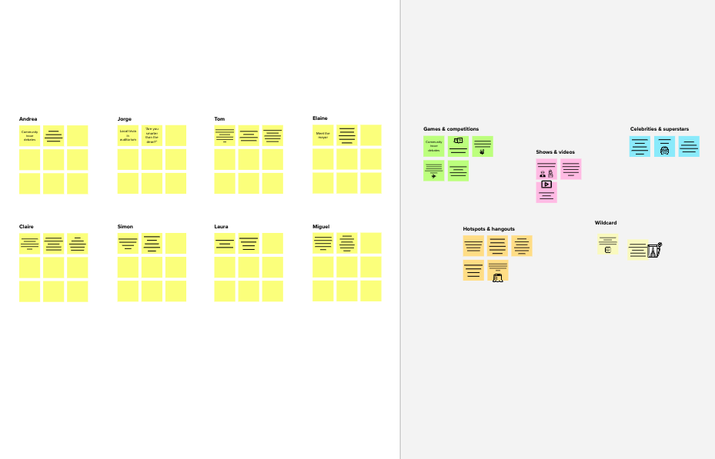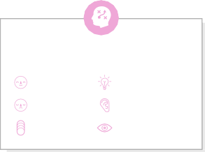

**Template**

**Need some inspiration?**

See a finished version of this template to kickstart your work.

[**Open example**](https://app.mural.co/template/e5a93b7b-49f2-48c9-afd7-a635d860eba6/93f1b98d-b2d2-4695-8e85-7e9c0d2fd9b9)